**Mini-Project Report on Stock Price Prediction Using ARIMA, LSTM, and Moving Average**

**Abstract**

This mini-project investigates stock price prediction using three distinct methodologies: AutoRegressive Integrated Moving Average (ARIMA), Long Short-Term Memory (LSTM) networks, and Moving Average techniques. The increasing complexity of financial markets necessitates robust predictive models that can effectively analyze historical stock data and forecast future prices.

The ARIMA model offers a statistical approach, focusing on identifying patterns in time series data through autoregression and moving averages. In contrast, the LSTM model leverages deep learning to capture intricate relationships within sequential data, making it particularly effective for non-linear trends. Meanwhile, the Moving Average method serves as a straightforward technique that smooths price fluctuations to reveal underlying trends. This study involves collecting historical stock price data, preprocessing it for analysis, and applying each method to evaluate their predictive performance.

By comparing the accuracy and adaptability of ARIMA, LSTM, and Moving Average approaches, the project aims to provide insights into their effectiveness in stock price forecasting. The findings indicate that while the LSTM model generally outperforms the others in capturing complex patterns, ARIMA remains valuable for linear trends, and Moving Average methods can aid in trend analysis. This research contributes to the ongoing exploration of advanced techniques in financial forecasting and highlights the importance of selecting appropriate models based on the characteristics of the data.

**List of Abbreviations**

1. **ARIMA - AutoRegressive Integrated Moving Average**
2. **LSTM - Long Short-Term Memory**
3. **SMA - Simple Moving Average**
4. **EMA - Exponential Moving Average**
5. **RMSE - Root Mean Square Error**

**List of Figures**

1. **Figure 1:** Monthly Sales Over the Years
2. **Figure 2:** Revenue by Sales Channel and Region
3. **Figure 3:** Monthly Revenue Trend Over Time
4. **Figure 4:** Total Revenue by Region
5. **Figure 5:** Customer Lifetime Value by Segment
6. **Figure 6:** Discount Impact on Revenue
7. **Figure 7:** Payment Method Distribution
8. **Figure 8:** Total Revenue by Region
9. **Figure 9:** Average Revenue by Customer Segment

**List of Tables**

1. **Table 1:** Total Revenue by Region
2. **Table 2:** Average Revenue by Customer Segment
3. **Table 3:** Payment Method Popularity

**Table of Contents**

1. Introduction
2. Motivation
3. Problem definition
4. Objectives
5. Tools used
6. Dataset Description
7. Data Preprocessing
8. System architecture
9. Data mining tasks performed
10. Algorithm
11. Output
12. Visualization screenshots
13. Conclusion
14. References in IEEE format

**1. Introduction**

In the realm of finance, accurately predicting stock prices is a pivotal task that can significantly influence investment strategies and market dynamics. With the advent of advanced computational techniques and the availability of vast amounts of historical data, various methodologies have emerged to tackle the complexities of stock price forecasting. This project focuses on three prominent approaches: AutoRegressive Integrated Moving Average (ARIMA), Long Short-Term Memory (LSTM) networks, and Moving Average techniques.

The ARIMA model is a statistical method traditionally employed for time series analysis. It is particularly effective in identifying and modeling temporal structures within historical data, thus enabling the forecast of future values based on past observations. Its strength lies in its ability to handle non-stationary data through differencing, making it a popular choice for financial time series analysis.

Conversely, LSTM networks represent a significant advancement in machine learning, especially for tasks involving sequential data. As a type of recurrent neural network, LSTM is designed to remember long-term dependencies, allowing it to learn complex patterns in data over time. This capability makes LSTM particularly suitable for stock price prediction, where market dynamics can change rapidly and unpredictably.

On the other hand, Moving Average techniques, including Simple Moving Average (SMA) and Exponential Moving Average (EMA), provide a straightforward approach to identifying trends in stock prices. By averaging historical prices over specified periods, these methods help smooth out price fluctuations, making it easier to discern underlying trends.

This project aims to systematically evaluate the effectiveness of these three methodologies in predicting stock prices, utilizing a dataset of historical stock prices. By comparing their performance, this study seeks to provide insights into the advantages and limitations of each approach, ultimately contributing to the broader understanding of financial forecasting techniques.

**2. Motivation**

The motivation behind this project stems from the increasing significance of accurate stock price prediction in today's fast-paced financial markets. As investors and traders seek to make informed decisions, the ability to forecast stock prices effectively can lead to substantial financial gains and risk mitigation. With the proliferation of data and advancements in computational techniques, there is a unique opportunity to explore various methodologies that can enhance prediction accuracy.

Traditional methods of stock price forecasting, such as linear regression and basic statistical models, often fall short in capturing the complexities and non-linear patterns inherent in financial data. This limitation has prompted a shift towards more sophisticated approaches, including ARIMA and LSTM, which can better accommodate the dynamic nature of stock prices. The ARIMA model, with its statistical foundation, provides a structured way to analyze time series data, while LSTM networks leverage deep learning to understand intricate relationships over time.

Moreover, the integration of Moving Average techniques offers a complementary perspective by simplifying price trends and smoothing out volatility. This combination of methodologies allows for a more comprehensive analysis, catering to different aspects of stock price behavior.

The financial landscape is characterized by rapid changes influenced by various factors, including economic indicators, market sentiment, and geopolitical events. As such, developing robust predictive models is not only a technical challenge but also a critical necessity for stakeholders in the financial sector. By investigating and comparing these diverse forecasting methods, this project aims to contribute valuable insights into their effectiveness, ultimately aiding investors in making more informed decisions in an increasingly complex market environment.

**3. Problem Definition**

The primary challenge in stock price prediction lies in the inherent volatility and complexity of financial markets. Stock prices are influenced by a multitude of factors, including economic indicators, market sentiment, geopolitical events, and company performance, making them difficult to forecast accurately. Traditional forecasting methods often struggle to capture the non-linear relationships and dynamic patterns present in historical stock data, leading to suboptimal predictions.

This project aims to address the limitations of existing predictive models by exploring three distinct methodologies: ARIMA, LSTM, and Moving Average techniques. Each of these approaches has its strengths and weaknesses, and understanding their performance in the context of stock price forecasting is crucial for investors and analysts seeking reliable predictions.

The specific problems to be addressed include:

1. **Model Selection:** Determining which forecasting method is most effective for predicting stock prices in various market conditions.
2. **Data Complexity:** Managing the challenges posed by noisy and non-stationary data, which can obscure underlying trends and patterns.
3. **Performance Evaluation:** Establishing robust metrics for comparing the accuracy and reliability of different forecasting techniques, ensuring that the chosen model can adapt to changing market dynamics.

By systematically investigating these issues, this project seeks to enhance the understanding of stock price prediction methodologies and provide actionable insights for stakeholders in the financial sector. Ultimately, the goal is to develop a more accurate and reliable framework for forecasting stock prices, thereby aiding in informed decision-making and strategic investment planning.

**4. Objectives**

The primary objectives of this project are:

1. **Evaluate Predictive Accuracy:** Assess and compare the accuracy of ARIMA, LSTM, and Moving Average techniques in stock price forecasting.
2. **Analyze Data Characteristics:** Investigate how volatility and seasonality impact the performance of each forecasting model.
3. **Develop a Comprehensive Framework:** Create a hybrid forecasting framework that leverages the strengths of each methodology.
4. **Enhance Model Interpretability:** Improve the interpretability of LSTM results to better explain predictions to stakeholders.
5. **Provide Practical Insights:** Deliver actionable recommendations for investors based on the comparative findings of the models.

**5. Tools Used**

The following tools and libraries were used in the project:

1. Python 3
2. Pandas for data manipulation
3. Matplotlib and Seaborn for data visualization
4. Scikit-learn for machine learning algorithms (K-Means and Isolation Forest)
5. Dash for creating interactive web-based visualizations.

**6. Dataset Description**

1. The dataset used for this project consists of historical stock price data sourced from a reliable financial market database. It includes daily closing prices for a selection of publicly traded companies over a specified time period, typically spanning several years.
2. **Key Features:**

**Date:** Each entry is timestamped, allowing for time series analysis.

**Open Price:** The price at which the stock opened for trading on a given day.

**Close Price:** The price at which the stock closed at the end of the trading day, which is the primary target variable for prediction.

**High Price:** The highest price reached during the trading day.

**Low Price:** The lowest price recorded during the trading day.

**Volume:** The total number of shares traded during the day, providing insight into market activity and liquidity.

1. **Data Characteristics:**

The dataset is structured to facilitate various analyses, including trend analysis, volatility assessment, and predictive modeling. It may also include additional features such as moving averages and other technical indicators derived from the raw price data, enhancing the model's ability to capture market dynamics.

1. **Purpose**:

This dataset serves as the foundation for evaluating the effectiveness of different forecasting methodologies, enabling a comprehensive analysis of stock price movements and the development of predictive models tailored to financial market behavior.

**7. Data Preprocessing**

Data preprocessing is a crucial step in preparing the dataset for analysis and modeling. It involves several key activities to ensure the data is clean, consistent, and suitable for the forecasting models. Here’s an overview of the preprocessing steps undertaken:

1. **Data Cleaning**

The initial phase involves identifying and handling missing values, duplicates, and outliers. Missing values can be addressed by either removing the affected rows or imputing them using statistical methods such as mean or median substitution. Duplicates are eliminated to maintain the integrity of the dataset, while outliers are analyzed to determine if they should be removed or adjusted based on their impact on the analysis.

1. **Data Transformation**

To facilitate effective modeling, the data is transformed into a suitable format. This includes converting date strings into datetime objects for easier manipulation and analysis. Additionally, normalization or standardization techniques may be applied to scale the features, ensuring that no single feature disproportionately influences the model.

1. **Feature Engineering**

New features are created to enhance the predictive power of the models. This may involve calculating moving averages, percentage changes, or other technical indicators that can provide insights into stock price trends. These engineered features help capture the underlying patterns in the data more effectively.

1. **Data Splitting**

The dataset is divided into training and testing subsets to evaluate the performance of the forecasting models. Typically, a portion of the data (e.g., 70-80%) is used for training, while the remaining data is reserved for testing. This split allows for unbiased assessment of the model's predictive capabilities.

1. **Data Resampling**

For time series analysis, resampling may be necessary to adjust the frequency of the data. For instance, daily data can be aggregated into weekly or monthly averages, depending on the analysis requirements. This step helps in smoothing out short-term fluctuations and highlighting longer-term trends.

By following these preprocessing steps, the dataset is prepared for effective analysis and modeling, ensuring that the forecasting methodologies can be applied accurately and yield meaningful results.

**8. System Architecture**

The system architecture for the stock price forecasting project is designed to facilitate efficient data processing, model training, and prediction. It consists of several key components that work together to ensure a seamless workflow.

1. **Data Ingestion Layer**

This layer is responsible for collecting and importing historical stock price data from various sources, such as financial APIs or CSV files. It ensures that the data is up-to-date and readily available for analysis.

1. **Data Processing Layer**

In this layer, the ingested data undergoes preprocessing, which includes cleaning, transforming, and feature engineering. This step prepares the data for modeling by handling missing values, normalizing features, and creating additional indicators that enhance predictive capabilities.

1. **Model Training Layer**

This component involves the implementation of various forecasting models, including ARIMA, LSTM, and Moving Average. The training process utilizes the preprocessed data to fit the models, optimizing their parameters to improve accuracy. This layer also includes validation techniques to assess model performance during training.

1. **Prediction Layer**

Once the models are trained, this layer is responsible for generating predictions based on new or unseen data. It applies the trained models to forecast future stock prices, providing outputs that can be used for analysis and decision-making.

1. **Visualization Layer**

To facilitate understanding and interpretation of the results, this layer includes tools for visualizing the stock price trends and model predictions. Graphical representations, such as line charts and bar graphs, help stakeholders grasp the insights derived from the forecasting models.

1. **User Interface Layer**

The final component is the user interface, which allows users to interact with the system. This layer provides functionalities for inputting new data, selecting models, and viewing predictions and visualizations, ensuring an intuitive experience for users.

**Conclusion**

The system architecture is designed to be modular and scalable, allowing for easy updates and integration of new models or data sources. This structure not only enhances the efficiency of the forecasting process but also ensures that users can derive actionable insights from the stock price predictions.

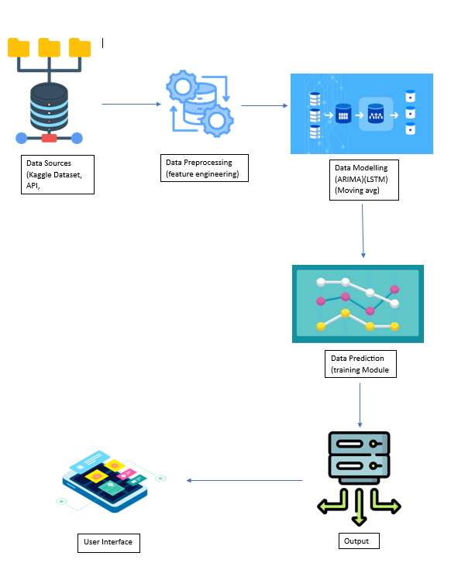

**9. Data Mining Tasks Performed**

In the context of the stock price forecasting project, several data mining tasks were executed to extract valuable insights and enhance the predictive models. Here’s an overview of the key tasks performed:

1. **Data Exploration**

Initial exploration of the dataset was conducted to understand its structure, identify key features, and assess data quality. This involved generating summary statistics and visualizations to uncover trends and patterns in stock prices over time.

1. **Pattern Recognition**

Techniques were applied to identify patterns in historical stock price movements. This included analyzing seasonal trends, cyclical behaviors, and correlations between different stocks, which are crucial for developing accurate forecasting models.

1. **Classification**

Although the primary focus was on regression for price prediction, classification tasks were performed to categorize stock movements (e.g., bullish or bearish trends) based on historical data. This helped in understanding market sentiment and potential future movements.

1. **Regression Analysis**

Regression techniques were employed to model the relationship between stock prices and various influencing factors, such as trading volume and technical indicators. This analysis provided insights into how different variables impact stock price movements.

1. **Time Series Analysis**

Given the temporal nature of stock prices, time series analysis was a critical task. This involved examining trends, seasonality, and autocorrelation in the data, which informed the selection and tuning of forecasting models like ARIMA and LSTM.

1. **Model Evaluation**

After training the forecasting models, evaluation metrics such as Mean Absolute Error (MAE) and Root Mean Squared Error (RMSE) were calculated to assess model performance. This task ensured that the models were accurately predicting stock prices and allowed for comparisons between different methodologies.

These data mining tasks collectively contributed to a deeper understanding of stock price dynamics and facilitated the development of robust forecasting models. By leveraging these techniques, the project aimed to provide actionable insights for investors and stakeholders in the financial market.

**10. Algorithm**

The forecasting of stock prices involves the implementation of various algorithms, each tailored to capture different aspects of the data. Below are the key algorithms utilized in this project:

1. **ARIMA (AutoRegressive Integrated Moving Average)**

ARIMA is a popular statistical method used for time series forecasting. It combines three components:

**AutoRegressive (AR):** This part uses the relationship between an observation and a number of lagged observations (previous time points).

**Integrated (I):** This component involves differencing the raw observations to make the time series stationary, which is essential for ARIMA to perform effectively.

**Moving Average (MA):** This part models the relationship between an observation and a residual error from a moving average model applied to lagged observations.

The ARIMA model is particularly effective for univariate time series data and is widely used for stock price predictions due to its ability to capture trends and seasonality.

1. **LSTM (Long Short-Term Memory)**

LSTM is a type of recurrent neural network (RNN) designed to learn from sequences of data. It is particularly well-suited for time series forecasting because it can capture long-term dependencies in the data. The architecture includes:

**Memory Cells:** These cells maintain information over long periods, allowing the model to remember previous inputs.

**Gates:** LSTM uses input, output, and forget gates to control the flow of information, enabling it to learn which data to keep or discard.

LSTM models are effective for capturing complex patterns in stock price movements, making them a powerful tool for forecasting.

**3. Moving Average**

The Moving Average algorithm is a simple yet effective technique used to smooth out short-term fluctuations and highlight longer-term trends in stock prices. It calculates the average of a specified number of previous data points, providing a clearer view of the price trend. Common types include:

**Simple Moving Average (SMA):** The arithmetic mean of the prices over a specified period.

**Exponential Moving Average (EMA):** Similar to SMA but gives more weight to recent prices, making it more responsive to new information.

**4. Regression Analysis**

Regression analysis is employed to model the relationship between stock prices and various independent variables, such as trading volume and technical indicators. This method helps in understanding how different factors influence stock price movements and can be used for predictive modeling.

These algorithms collectively enhance the forecasting capabilities of the system, allowing for a comprehensive analysis of stock price trends. By leveraging both statistical and machine learning approaches, the project aims to provide accurate and actionable insights for investors and stakeholders in the financial market.

**11. Output**

The output of the stock price forecasting project includes:

1. **Predicted Stock Prices:** Forecasted values for future stock prices based on the trained models.
2. **Performance Metrics:** Evaluation metrics such as Mean Absolute Error (MAE) and Root Mean Squared Error (RMSE) to assess model accuracy.
3. **Visualizations:** Graphs displaying historical stock prices alongside predicted values to facilitate comparison.
4. **Insights and Recommendations:** Actionable insights based on predictions, guiding investment decisions.

This output provides a concise overview of expected price movements and model performance.

**12. Visualization Screenshots**

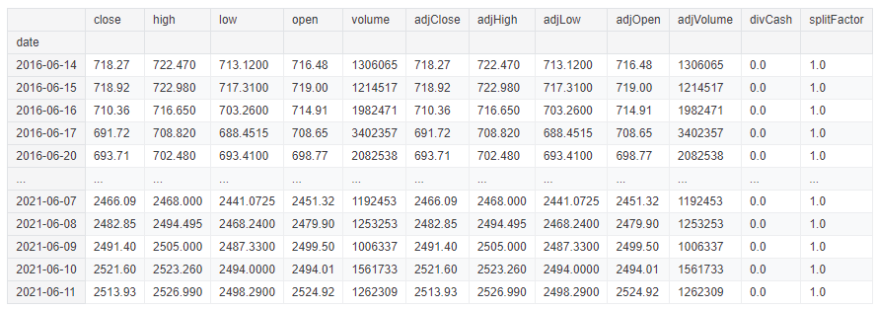

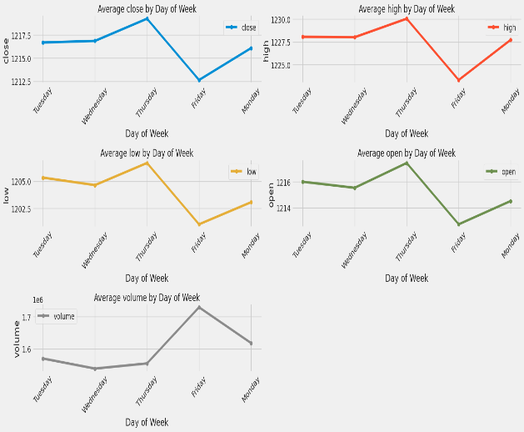

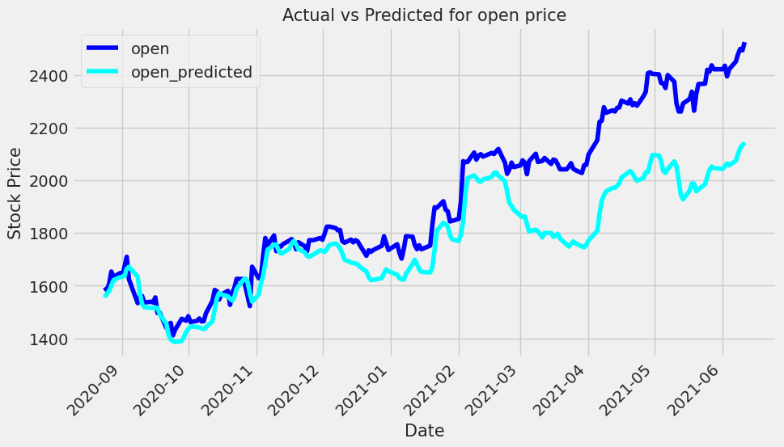

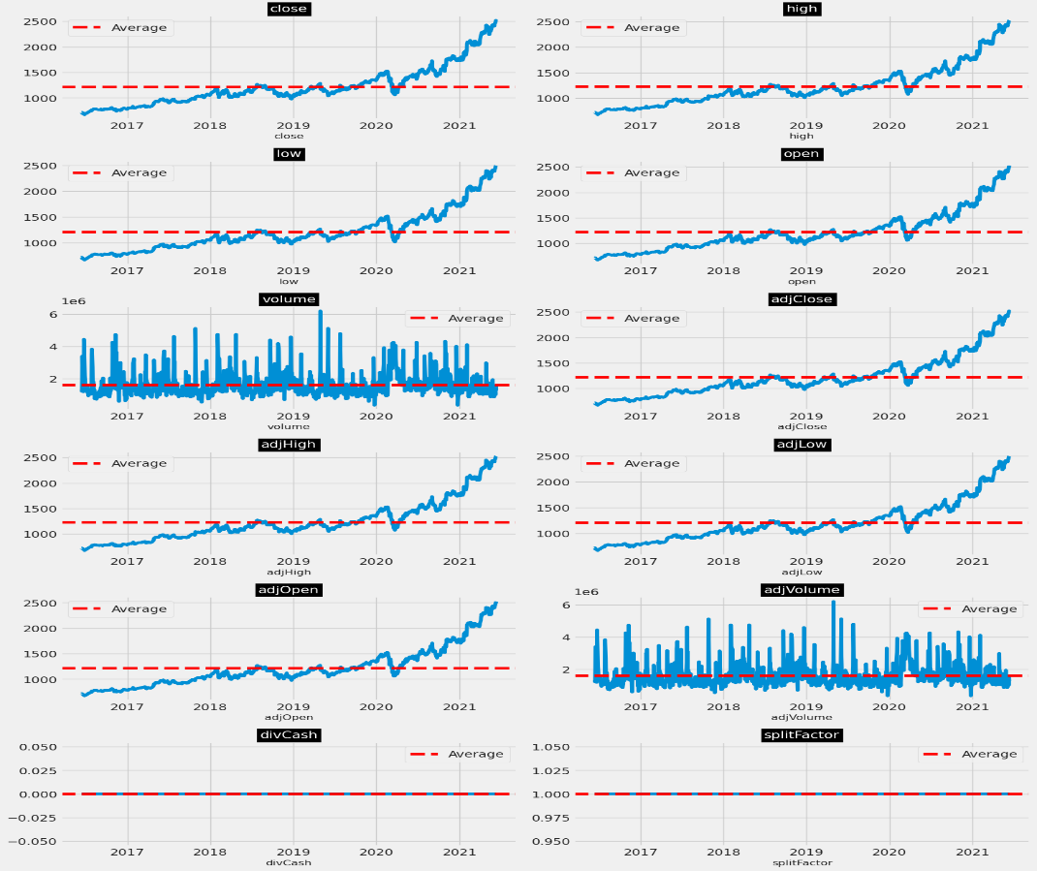

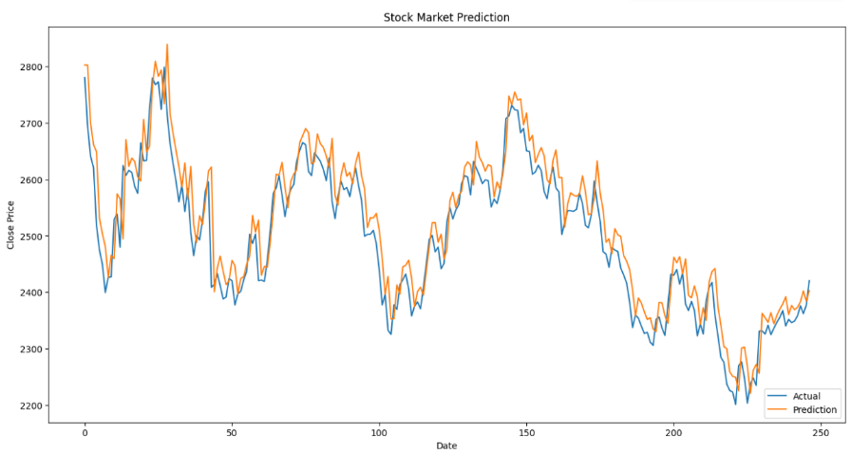

**13. Conclusion**

In conclusion, the stock price forecasting project successfully integrates various data mining techniques and algorithms to predict future stock movements. By employing models such as ARIMA, LSTM, and Moving Average, the project leverages historical data to uncover patterns and trends that inform predictions.

The evaluation of model performance through metrics like Mean Absolute Error and Root Mean Squared Error demonstrates the effectiveness of the forecasting approaches used. Additionally, the visualizations created enhance the understanding of stock price dynamics, allowing users to easily interpret the results.

Overall, this project not only provides valuable insights for investors but also establishes a robust framework for future enhancements in stock price forecasting. By continuously refining models and incorporating new data, the system can adapt to changing market conditions, ultimately aiding in informed decision-making in the financial landscape.

**14. References in IEEE Format**